
CLEAR REFLECTION

MIRROR CATEGORY
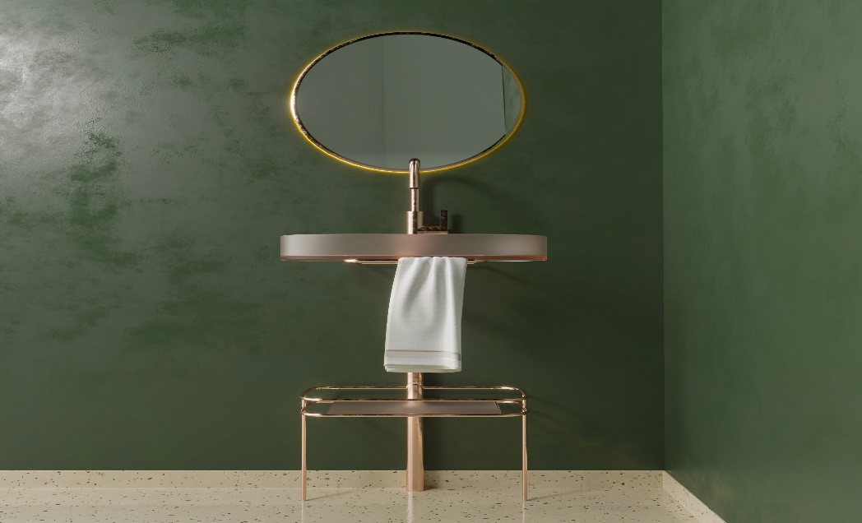
“DECORATIVE MIRROR”
The decorative mirror is a perfect blend of elegance, craftsmanship, and modern design, created to enhance the beauty of any interior space. Designed not only as a functional mirror but also as a statement décor piece, this mirror adds depth, light, and sophistication to its surroundings. The frame is carefully crafted using high-quality materials and finished with a refined decorative touch that complements both contemporary and classic interiors. Whether placed in a living room, bedroom, hallway, or dining area, the decorative mirror instantly elevates the overall ambiance of the space by reflecting light and creating a sense of openness.This mirror features premium-quality glass that provides a clear, distortion-free reflection, ensuring both beauty and usability. The decorative frame is designed with attention to detail, offering intricate patterns or smooth luxury finishes that enhance its visual appeal. It is built with durability in mind, making it suitable for long-term use while maintaining its original shine and elegance. The mirror is easy to install and can be mounted securely on the wall, making it a practical choice for residential as well as commercial spaces such as boutiques, salons, hotels, and luxury showrooms.

